**Week-1**

**Extraction , Load, Transform**

Step 1: Open Power Bi Application.

Step 2: Click On The Blank Report.

Step 3:In Home Click On The Get Data On The Top And Select The text/CSV.

Step 4: Once The File Selected Wait For A Few Seconds And

The File Is Visible With Some Options On The Lower

Side. (Load, Transform, Cancel).Click On Load.

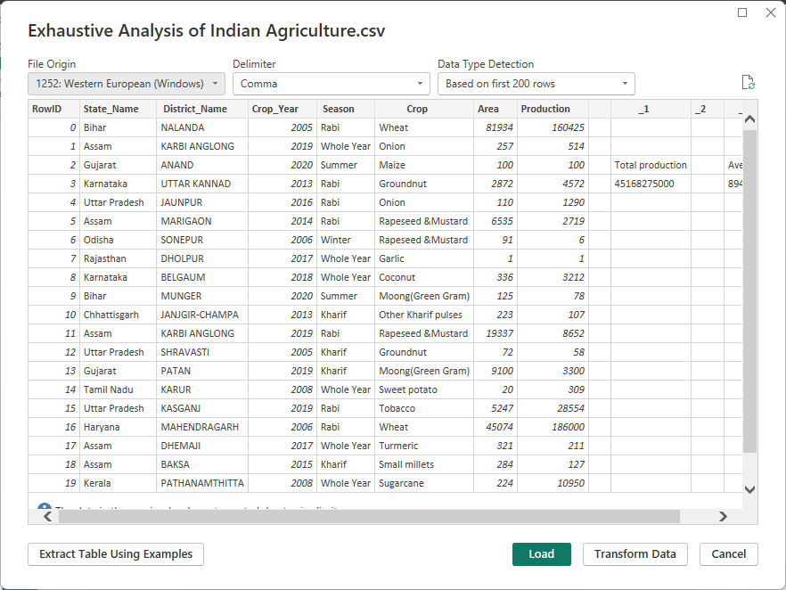

Step 5: We Can See The Data Is Loaded To Power Bi Application.

Step 6: Click On The Transform Data On The Top.

Step 7: It Redirects To The Power Query Editor.

Step 8: On The Right Side In The Applied Steps Section, We Can

See The Operations/Manipulations That Are Done By the User.

Step 9: To Delete A Column, Right Click The Column And

Select Remove.

Step 10: In The Below Image Row Id And Other unnecessary Columns Are Removed.

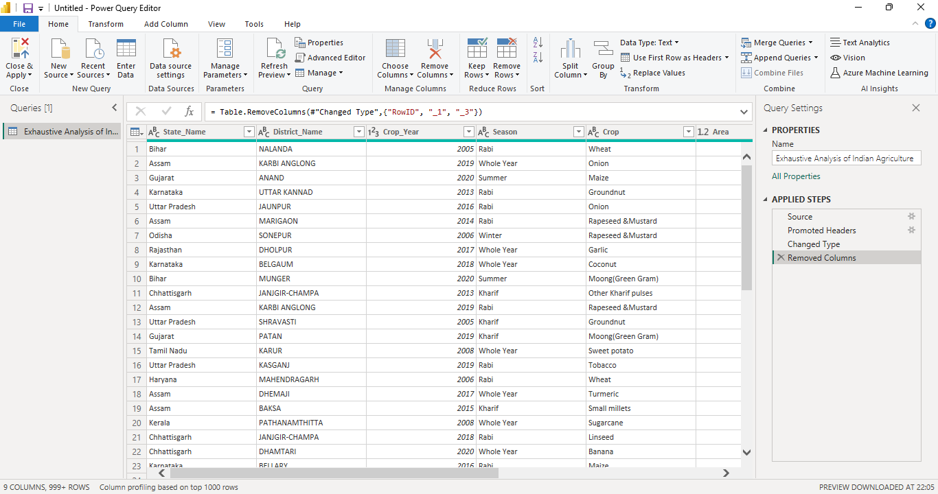

Step 13:Check for duplicate Data ,Blank Rows, Errors in the Data.

Step 14: To Undo The Previous Step(S) Click On The Cross Mark

Beside The Step In The Applied Steps Section.

Step 15: To Save The Updated Data Click On The Close And

Apply Option On The Top Left And Choose Close And Apply.